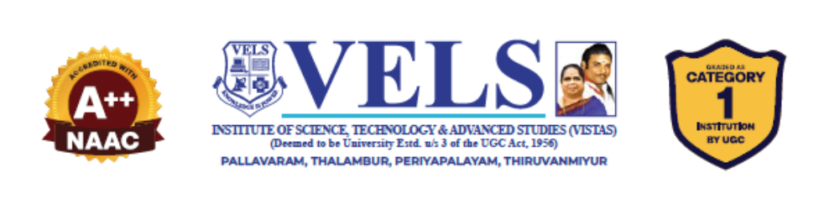

TechPilot: An AI-Guided Personalized Learning and Career Readiness Platform for Technology Students

Mohammed Afaf Samar, Sabarivasan, Manikandan

Guide: Dr. A. Manikandan
Department ofComputer Science and Engineering (Artificial Intelligence & Machine Learning) Vels Institute ofScience, Technology & Advanced Studies (VISTAS), Chennai, India

ABSTRACT
In today's competitive job market, many students and aspiring developers struggle to find a structured path to learn technology skills and secure suitable employment. This project presents TechPilot, an intelligent career guidance application that bridges the gap between self-learning and career readiness in the technology domain. The application offers curated learning tracks across multiple in-demand domains, including Web Development covering HTML, JavaScript, React, and Projects; Machine Learning covering Python, Statistics, core ML concepts, and Projects; UI/UX Design covering design principles, Figma, UX research, and Portfolio building; Cybersecurity covering Networking, Linux, Security, and Projects; and Data Science covering Python, SQL, Statistics, and Projects. Based on the user's performance, interests, and periodic skill-assessment results, the system recommends the most suitable career path and highlights matching job openings or internship opportunities, along with resume-building guidance, interview preparation resources, and progress-tracking dashboards. By integrating structured learning modules with data-driven career recommendations, TechPilot removes the need for learners to depend on scattered resources and generic advice. The system was implemented using a client-server architecture with a responsive front-end and a backend database storing user progress, skill levels, and job-matching data. Testing with sample users showed that the guided learning approach improved skill retention and helped users identify clearer career goals compared to unstructured self-learning. This project demonstrates how combining career counselling with skill development across multiple technology domains can create an effective, accessible pathway for students to learn in-demand skills and achieve employment in the technology industry.
Key words: Career Guidance, Machine Learning, UI/UX Design, Job Recommendation, Skill Assessment

